**EXCEL EXERCISE**

1. Change the number format to English (united states).
2. The customer wants the report to include order details. Insert a new row at the top of the dataset. Enter the column names in each column.

“Order ID”,” Product”, “Quantity Ordered”, “Price Each”, “Order Date”. Format the column names to Bold and centered. Must use keyboard shortcuts.

1. Sara the regional sales head wants to derive insights on the pricing of products. Introduce a functionality in the report so that when the product ID and order date are input, Sara can obtain the item and price. display “Not found” if values are not present. Must use excel functions.

Example as below:

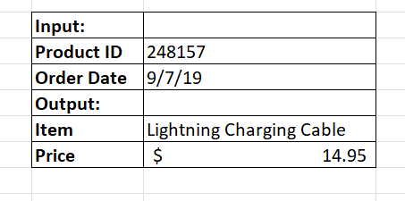

1. Sara looked at the report and she would like to the division by zero error to be replaced by Product ID and Name combination. Refer dataset q4 sheet for the same. Must use excel functions.
2. Henry the inventory manager wants a report of all the unique products sorted in alphabetical order. Blank cells should not be considered. Refer to q5 sheet for the dataset.

Must use excel functions.

1. The pricing analyst wants to see the products which are priced above the average price of the given products in the dataset q6. Indicate them in green shade.
2. The CMO wants to understand the number of products per category per region. Create a pivot for dataset q7 to inform him the same. He also needs average revenue added to the analysis. Also add slicer to filter the data at region level.
3. The pricing team wants to categorize their products by price ranges. Create 5 marketable price ranges and create a histogram for the resulting dataset from q3 using data analysis.
4. In the dataset q9 sheet, conditional format the students who has grades above class average.
5. For the dataset q3, the pricing team wants to see if there is a change in pricing strategy by day of the week. calculate the average quantity order per day of the week and plot it visually.